Telemetry Project Wokring with Ingress Controller -ALB

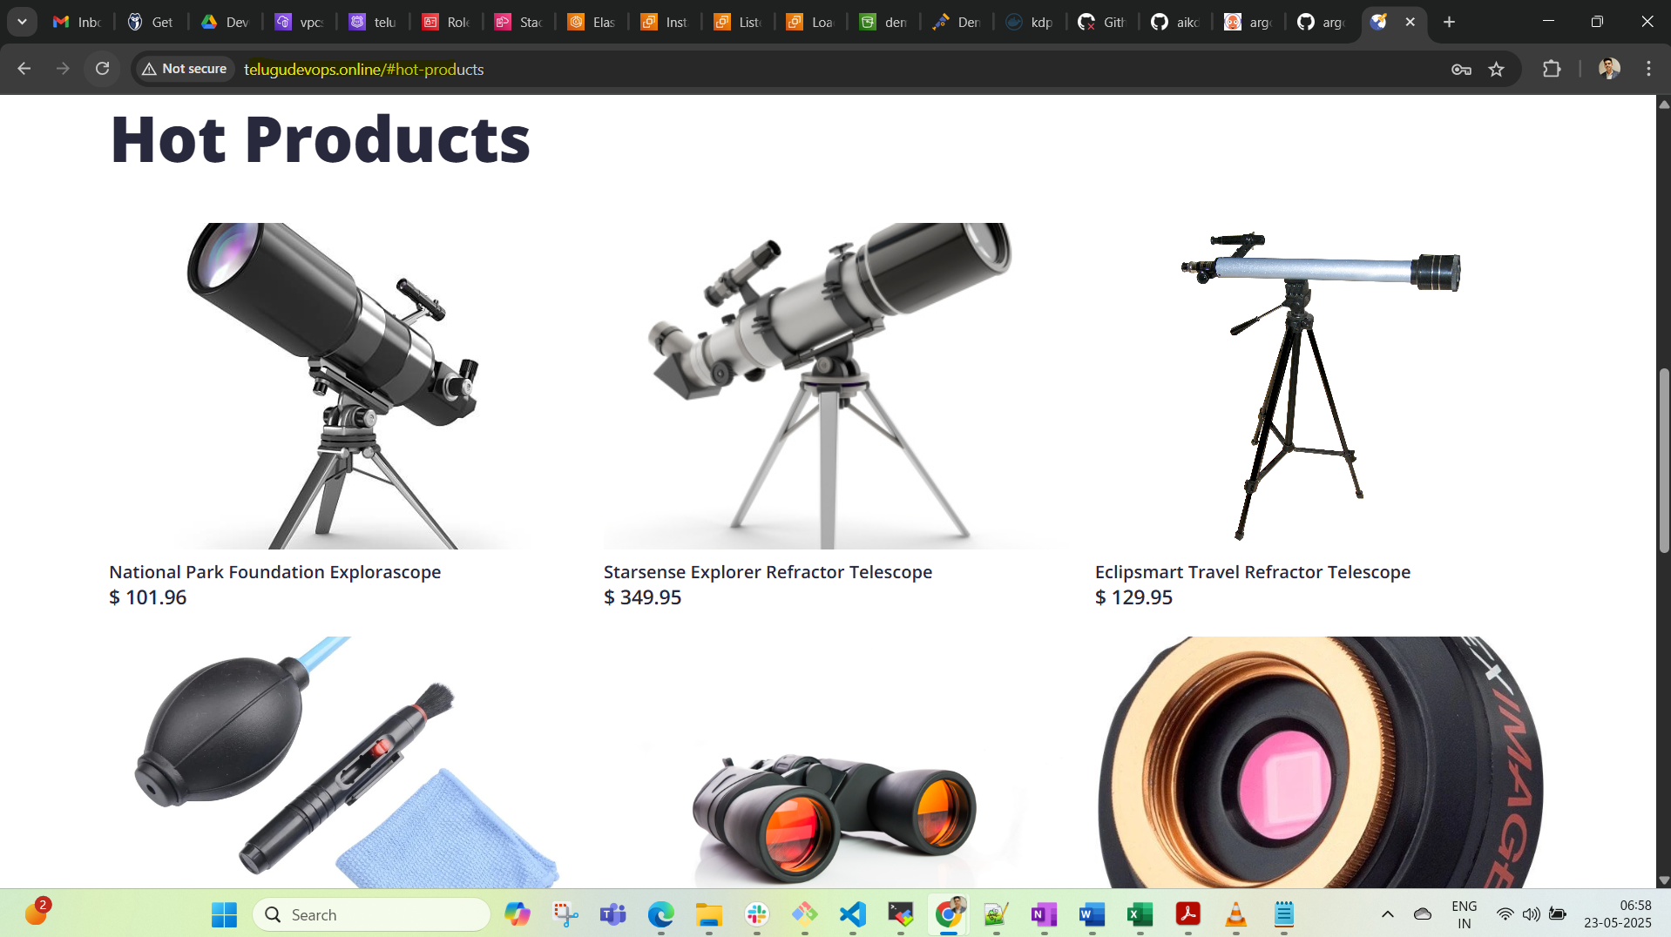

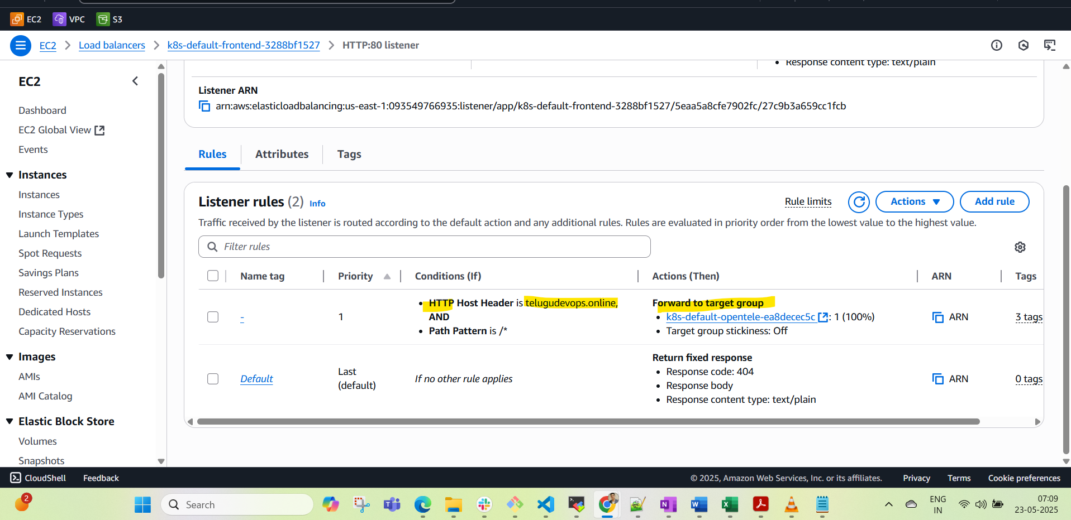

EKS SG:

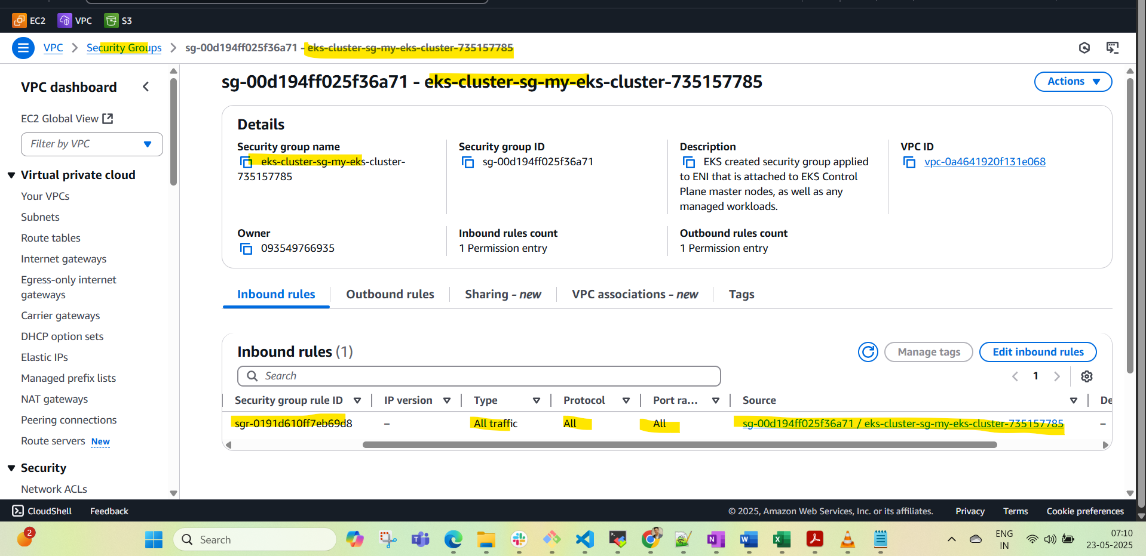

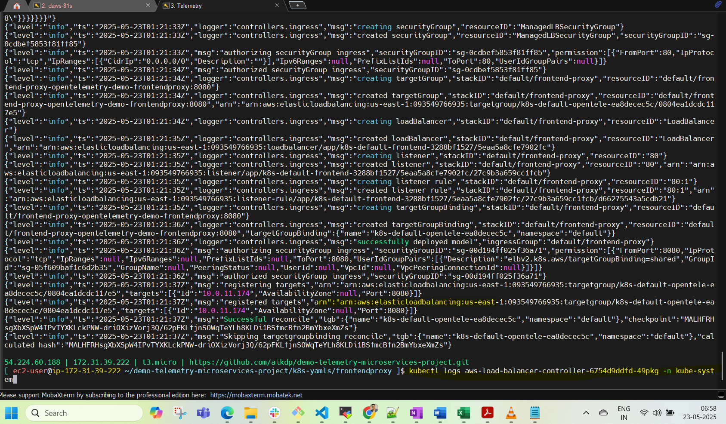

Clsuetr:

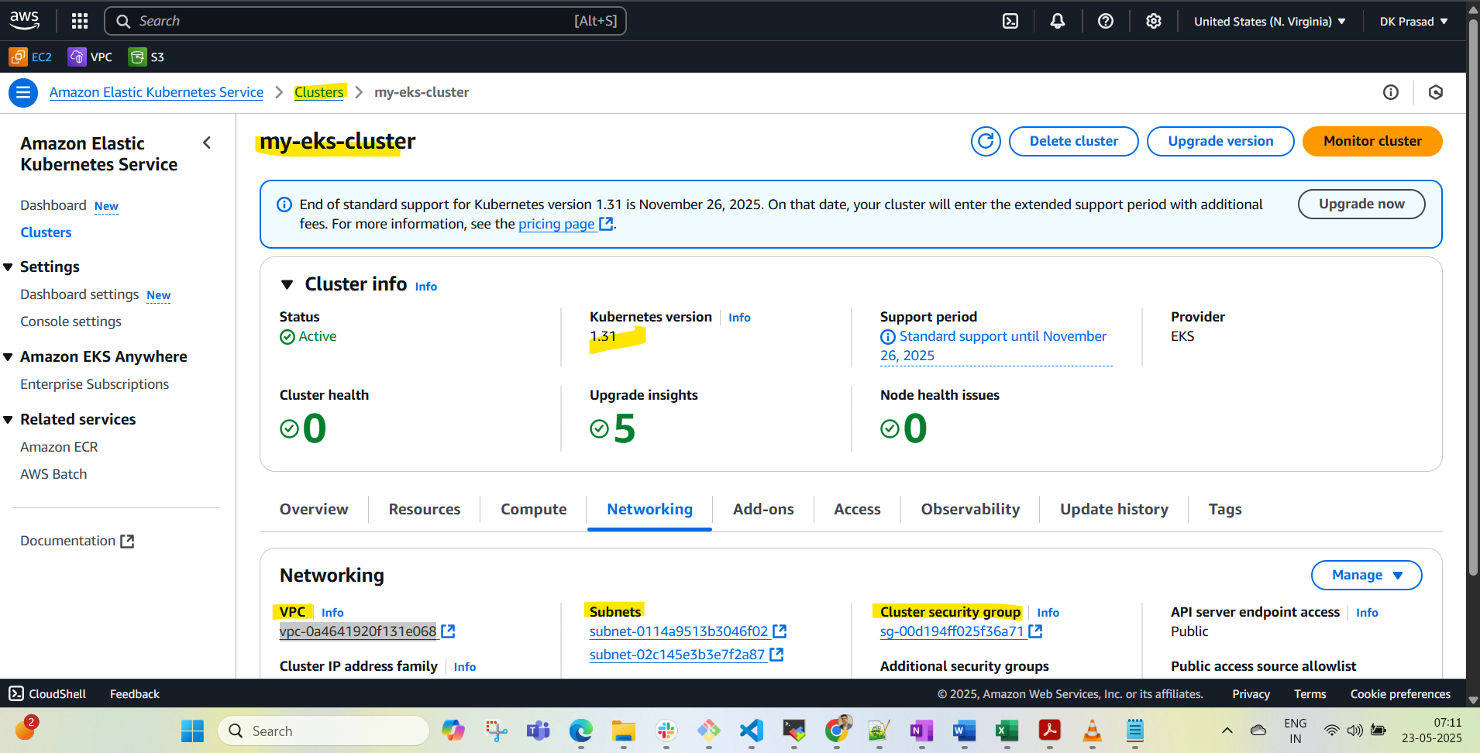

VPC ID:

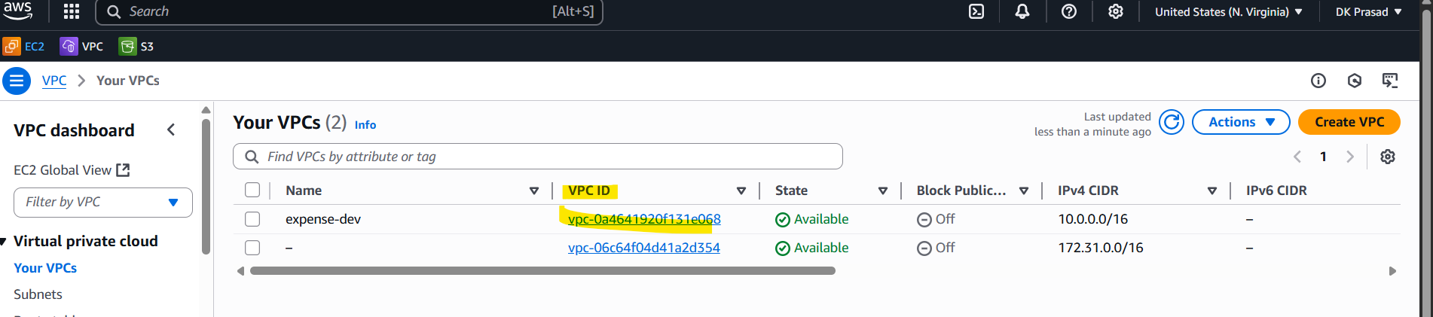

Subnets:

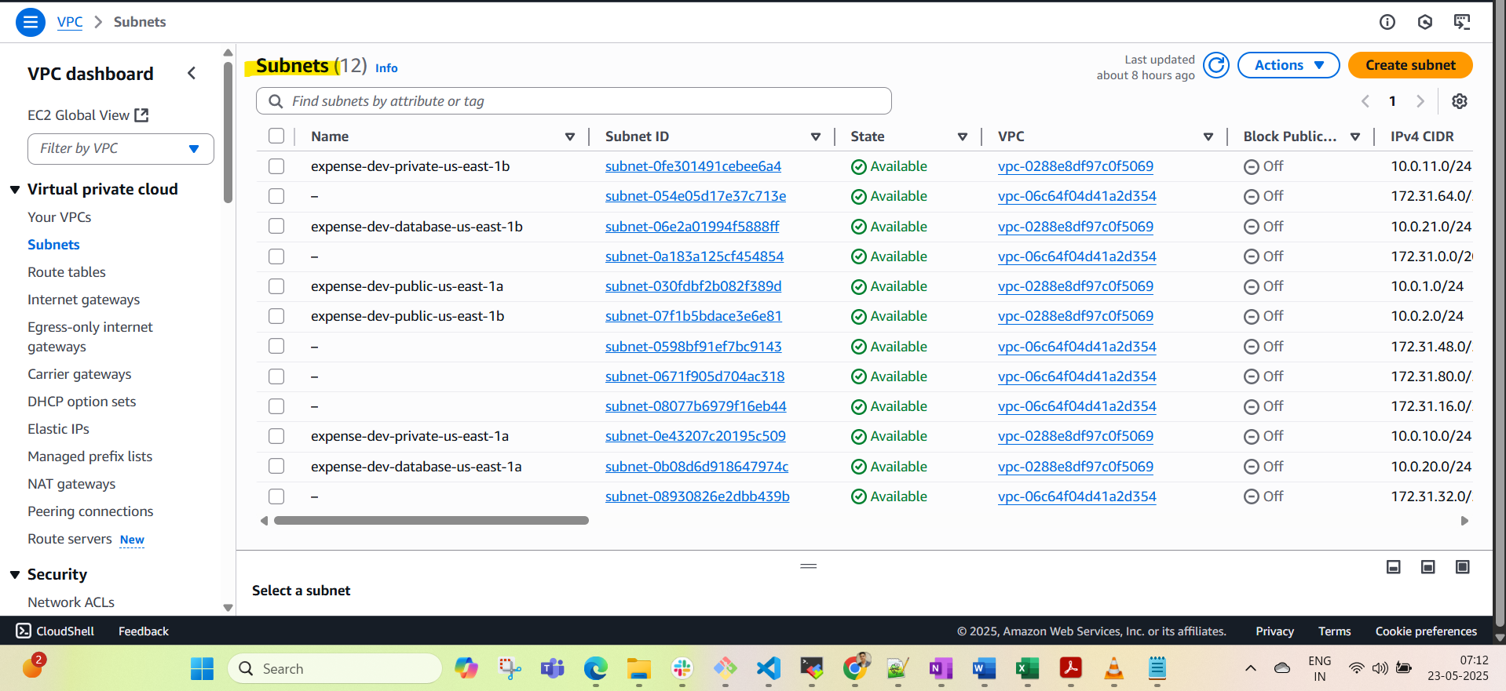

EIP:

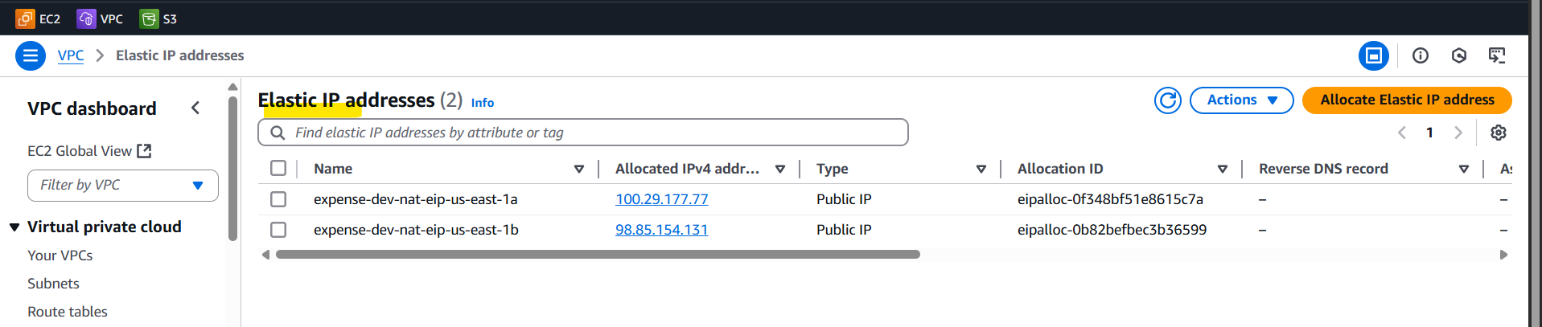

NAT GW:

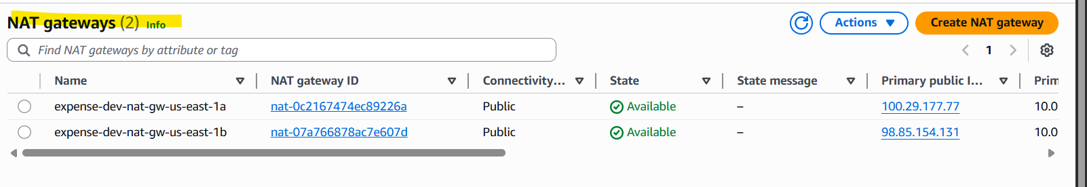

Route 53 Records:

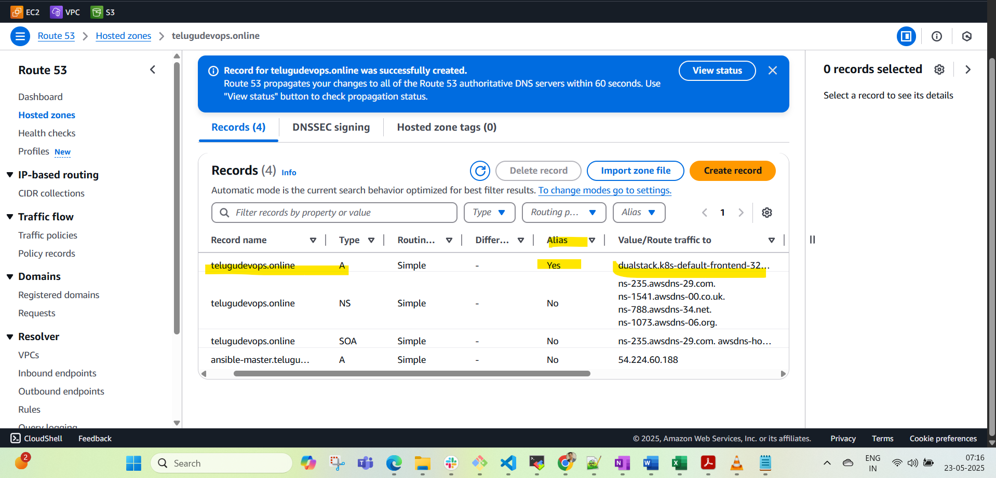

ING:

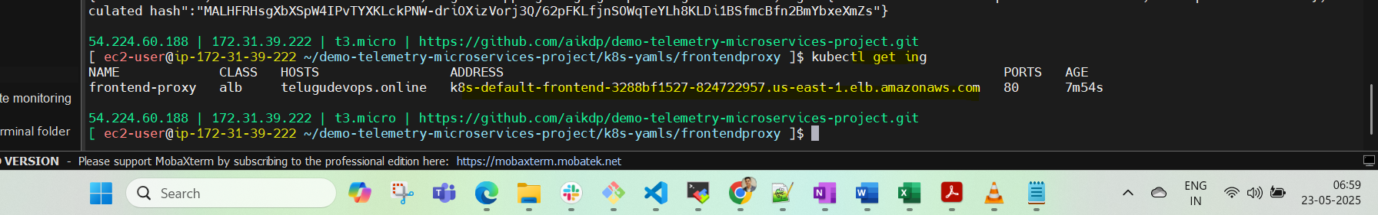

LB-AWS

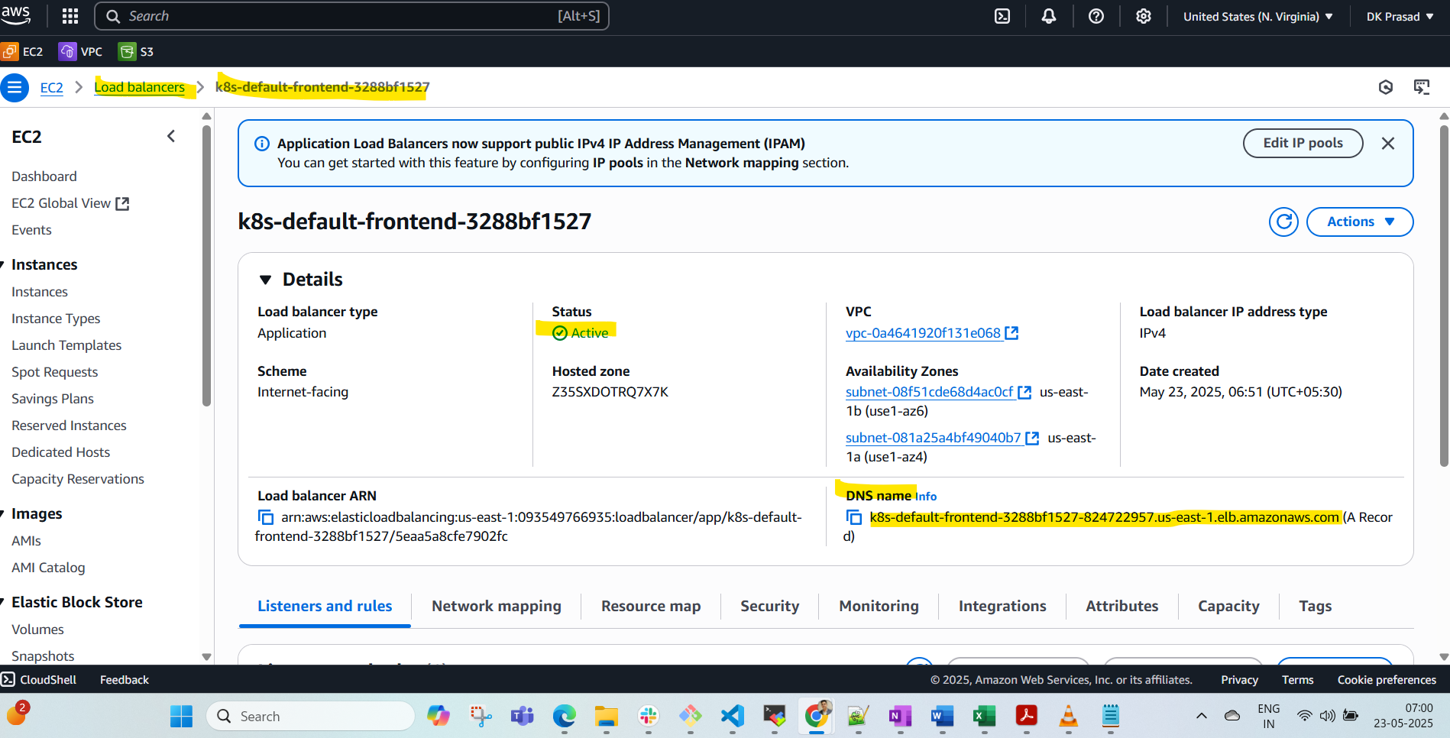

Ingress Class:



EKS Update; after Aws configure(use same user credentials which is created TF code of EKS)

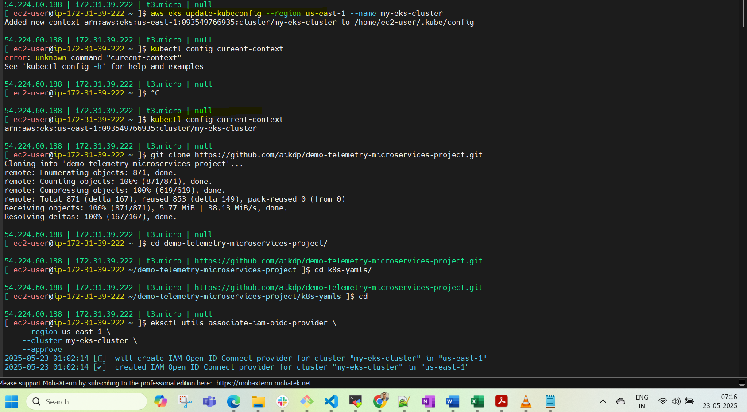

Pods-Running:

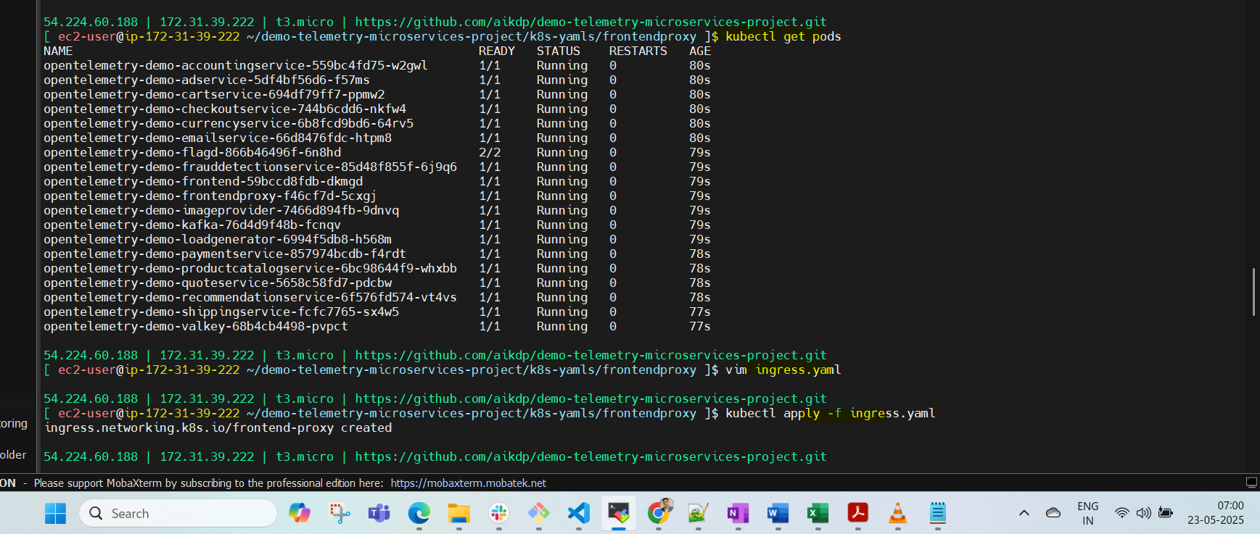

SVC: Running

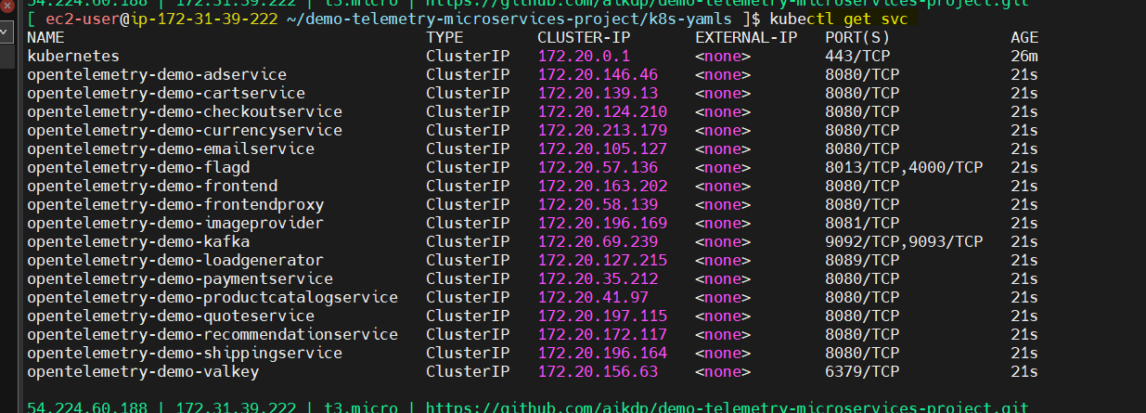

Create OIDC Orovider and IAM policy json download latest:

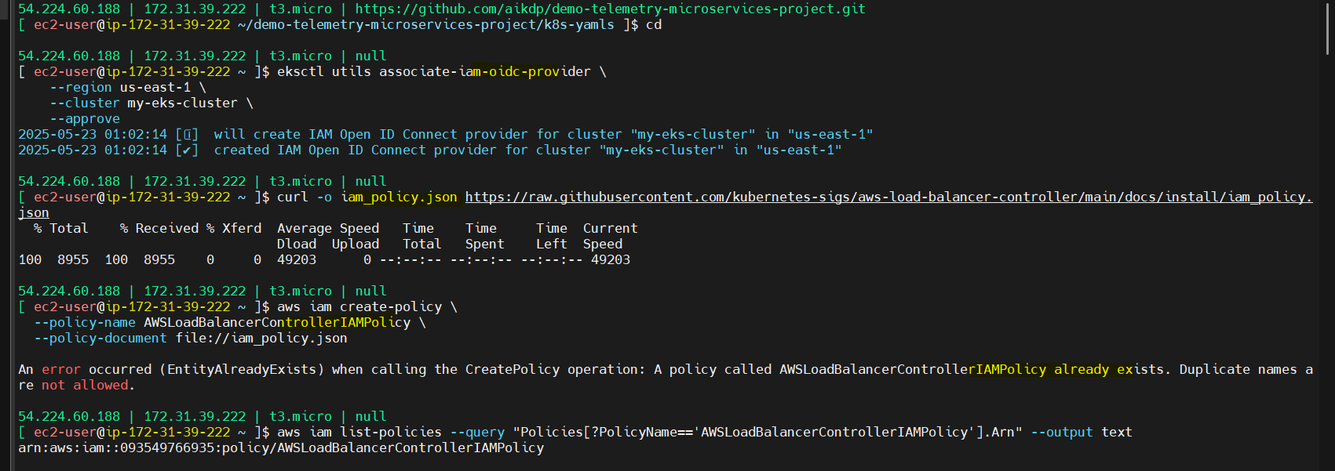

Create Policy, check if already exists then rename the policy and apply:

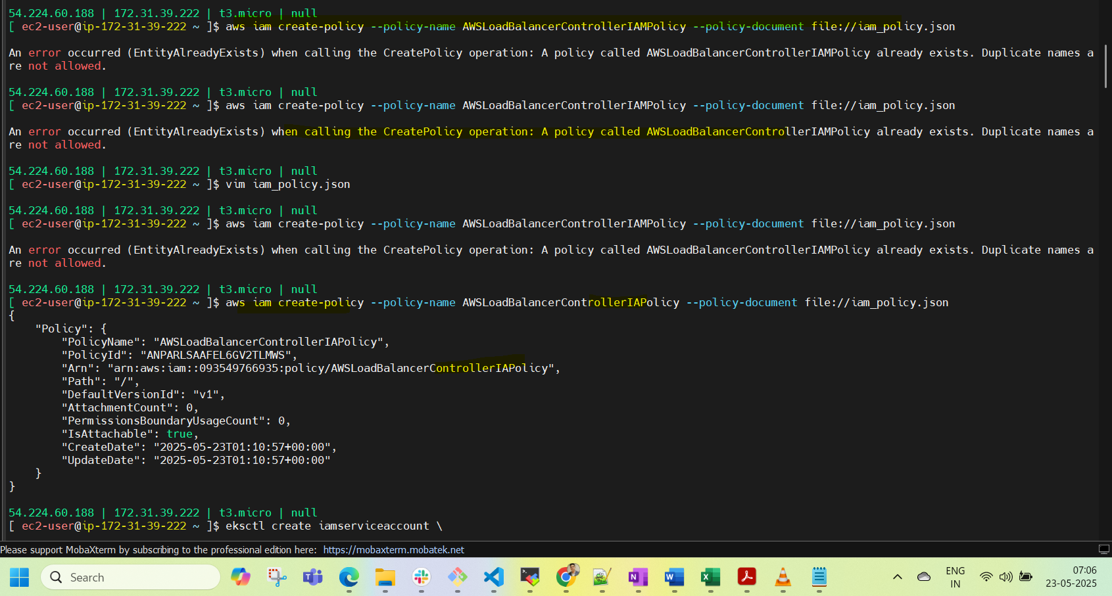

Craete Service Accounts and if already exists then delete in CF stack and Reapply:

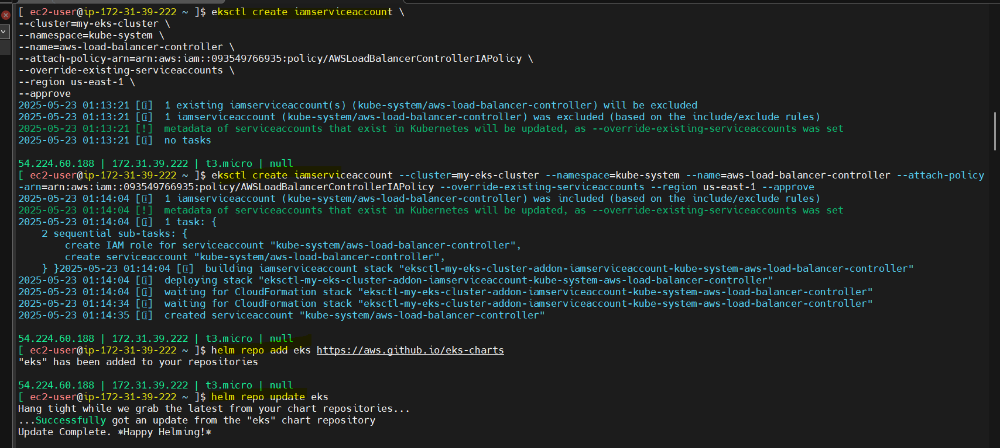

helm install aws-load-balancer-controller eks/aws-load-balancer-controller -n kube-system --set clusterName=my-eks-clutser --set serviceAccount.create=false --set serviceAccount.name=aws-load-balancer-controller --set region=us-east-1 --set vpcId=vpc-0a4641920f131e068

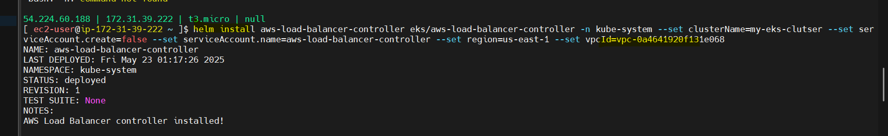

AWS load balancer controller: Running

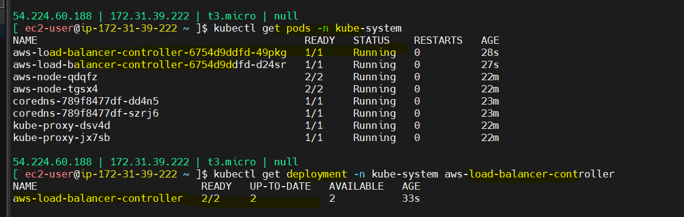

IAM Policies:

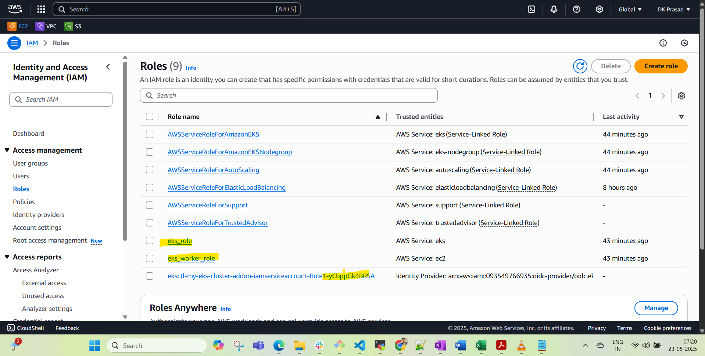

DELETE the AWS LOAD BALANCER (delete Ingress **kubectl delete -f ingress or kubectl delete <ing-name>** ): BEFORE You destroy the infra

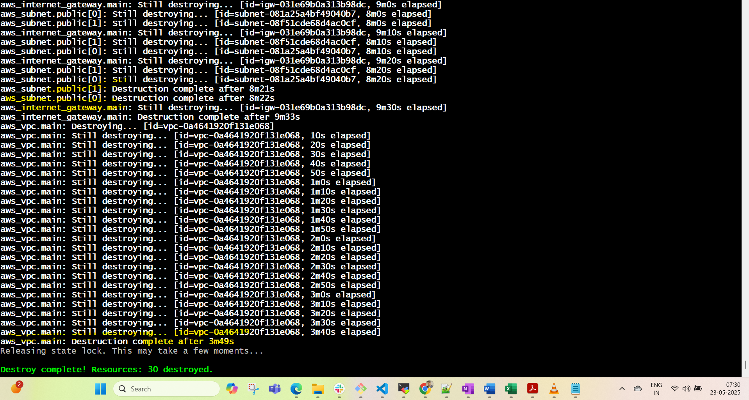

Note: Delete the SG Group manually if you not deleted the ingress in CLI